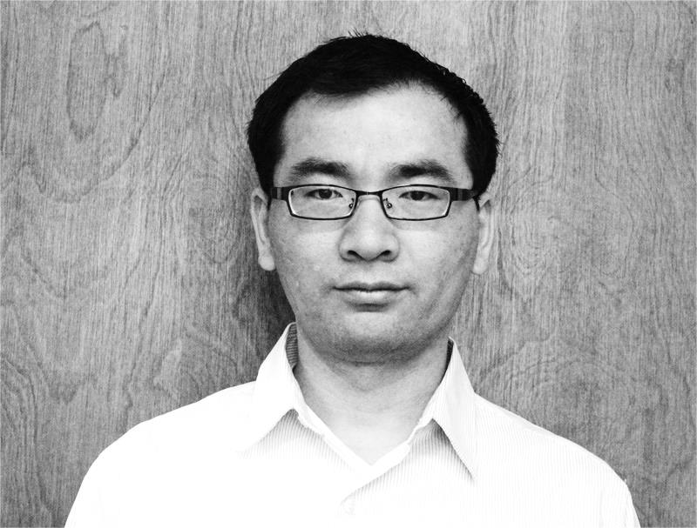**Tongchao Nan**

**University of Arizona**

**1133 E James E Rogers way**

**Tucson AZ 85721 USA**

**Email: tcnan@email.arizona.edu**

**Tel: (520) 621-1380**

**PROFILE:**

Pursuing Ph.D. under supervision of Drs. Shlomo P. Neuman and C. Larry Winter at Department of Hydrology and Water Resources, the University of Arizona  
Major: Hydrology and Water Resources  
Minor: Applied Mathematics.

**ACADEMIC DISTINCTIONS AND AWARDS:**

* **Galileo Circle Scholar** from College of Science, University of Arizona (spring 2014)
* **Hydrology Fellowship Award** from Department of Hydrology and Water Resources, University of Arizona (spring 2014)
* **Graduate College Fee Scholarship** from Department of Hydrology and Water Resources, University of Arizona (fall 2010 ~ spring2011)
* **Graduate Fellowship** from Department of Hydrology and Water Resources, Nanjing University (2007 - 2010)
* **Excellent Undergraduate Thesis Award**, Nanjing University (June 2007)
* **Excellent Student Award**, Nanjing University (June 2007)
* **National Scholarship**, Ministry of Education, P. R. China (2004 - 2006)

**PUBLICATIONS AND MEETINGS:**

**Articles**

* **Nan Tongchao**, Jichun Wu. Groundwater parameter estimation using the ensemble Kalman filter with localization. *Hydrogeology Journal*, Vol. 19(3):547-561, 2011.
* Harpold Adrian, Joel Biederman, Katherine Condon, Manuel Merino, Yoganand Korgaonkar, **Tongchao Nan**, Lindsey Sloat, Morgan Ross, Paul Brooks. Changes in snow accumulation and ablation following the Las Conchas Forest Fire, New Mexico, USA. *Ecohydrology*, DOI: 10.1002/eco.1363, 2013.
* Alberto Guadagnini, Shlomo Neuman, **Tongchao Nan**, Monica Riva, C. Larry Winter. Intra- and Inter-Layer Statistical Scaling of Deep Neutron Porosity Increments and Peaks Over Thresholds. *Hydrology and Earth System Sciences* (under review).

**Conferences, Proceedings and Meetings**

* **Nan Tongchao**, Shlomo Neuman, Alberto Guadagnini, Monica Riva, C. Larry Winter. Scaling and Extreme Value Analysis of Hydrogeological Variables with Application to Neutron Porosity Well Log Data in Oilfields. *23th Annual El Dia Del Agua showcase*, April 2014
* **Nan Tongchao**, Shlomo Neuman, Alberto Guadagnini, Monica Riva, C. Larry Winter. Extreme Value Analysis of Sub-Gaussian Random Fields Subordinated to tfBm/tfGn. *American Geophysical Union Fall Meeting*, December 2013
* **Nan Tongchao**, Shlomo Neuman, C. Larry Winter, Alberto Guadagnini, Monica Riva. Generation and Extreme Value Analysis of Sub-Gaussian Random Fields Subordinated to tfBm or tfGn. *22th Annual El Dia Del Agua showcase*, March 2013.
* **Nan Tongchao**, Shlomo Neuman, C. Larry Winter, Monica Riva, Alberto Guadagnini. Extreme Value Analysis on Air Permeabilities Measured on a Block of Tuff. *21th Annual El Dia Del Agua showcase*, March 2012.
* **Nan Tongchao**, Jichun Wu. Parameter Estimation in Groundwater Models via Localized Ensemble Kalman Filter. *The 7th International Conference on Calibration and Reliability in Groundwater Modeling* (ModelCARE2009). Wuhan, China, September 2009.

**ACADEMIC BACKGROUND:**

* Pursuing Ph.D. in Hydrology and Water Resources at University of Arizona with Cumulative Grade Point Average (GPA) **3.939/4.000**. (August 2010 – current)
* Master of Engineering in Hydrology and Water Resources at Nanjing University with cumulative GPA **4.7/5.0**. (September 2007 – June 2007)
* Bachelor of Science in Hydrology and Water Resources Engineering, Nanjing University with cumulative GPA **4.6/5.0, ranked 1st of 101**. (September 2003 – June 2007)

**PROFESSIONAL SERVICES AND AFFILIATION:**

* Graduate Research Assistant, Department of Hydrology and Water Resources, the University of Arizona (2010 - current)
* Member of American Geophysical Union (since 2010)
* Seminar Assistant, Department of Hydrosciences, Nanjing University (2008 – 2010)
* Member of joint geological field training group with students from Iowa University (2007)
* Assistant of Academic Dean, Department of Earth Sciences, Nanjing University (2006 - 2007)
* Member of Summer Training Camp, Daqing Oilfield, PetroChina Company Limited (2004)

**MASTER THESIS ABSTRACT:**

“*Filter Algorithms for Hydrogeological Parameter Estimation*”

It is always one of the key problems in hydrogeology to estimate parameters in groundwater models efficiently and accurately, since reliability of models is greatly dependent on model parameters. In recent years, filter methods used in information fusion have drawn the growing attention of hydrogeologists. Filter techniques represented by Ensemble Kalman Filter expose their deficiencies while showing their capability of incorporating observations of various types from different sources to update the state of the model. In this study, Kalman filter theory, therotical base of many common filters, is introduced and filter algorithms already used in hydrogeology (such as Ensemble Kalman Filter, Deterministic Ensemble Kalman Filter, Karhunen-Loeve based Kalman Filter, and so on) are systematically organized, tested and compared. On this basis, Ensemble Kalman Filter is amended through Explicit Localization and Implicit Localization in order to solve sampling noise problem which it badly suffers from when the ensemble is small. How to configure these two schemes of modification is studied. And a new filter, Ensemble H-infinity Filter, is introduced to estimate hydrogeological parameters for the purpose of overcoming Kalman theory’s limitation that noises to be dealt with must be Gaussian white noises. These filter algorithms are implemented and explored in three synthetic groundwater models and the results are analyzed in detail.

**Ph.D. DISSERTATION TITLE:**

“*Scaling and Extreme Value Analysis of Hydrogeological Variables with Application to Neutron Porosity Well Log Data in Oilfields*”

**PROFESSIONAL SKILLS:**

* Strong programming skills (Fortran, MATLAB, Mathematica, C, R)
* Strong background in Applied Mathematics (complex analysis, differential/integral equations, spectral theory, Fourier analysis, theory of probability, statistics, stochastic processes etc.)
* Experienced with use of various plotting and visualization software e.g. Surfer, Tecplot, MS Excel, MATLAB etc.
* Experienced with various groundwater flow and transport modeling software packages and fluid analysis tools e.g. MODFLOW, FEMWATER, MT3DMS etc.
* Extensive implementation of field survey techniques such as hydrological survey, geological survey and snow survey

**PERSONAL INFORMATION:**

**Date of birth:** May 1st, 1986

**Nationality:** China

**REFERENCES:**

**Dr. Shlomo Neuman** (Ph. D. advisor)

Regents’ Professor  
Department of Hydrology and Water Resources, the University of Arizona  
1133 E James E. Rogers Way, Tucson AZ 85721, USA

Email: neuman@hwr.arizona.edu Tel: +1-520-621-7144

**Dr. C. Larry Winter** (Ph. D. co-advisor)  
Professor and Department Head  
Department of Hydrology and Water Resources, the University of Arizona  
1133 E James E. Rogers Way, Tucson AZ 85721, USA  
Email: winter@email.arizona.edu Tel: +1-520-626-8468

**Dr. Ty Ferre** (Ph.D. committee member)

Professor  
Department of Hydrology and Water Resources, the University of Arizona  
1133 E James E. Rogers Way, Tucson AZ 85721, USA  
Email: ty@hwr.arizona.edu Tel: +1-520-621-1422

**Dr. Monica Riva** (Ph.D. committee member)

Associate Professor  
Dipartimento di Ingegneria Civile e Ambientale (DICA), Politecnico di Milano  
Piazza L. Da Vinci, 32-20133 Milano, Italy   
Email: monica.riva@polimi.it Tel: +39-02-2399-6214

**Dr. Alberto Guadagnini** (cooperator)

Professor  
Dipartimento di Ingegneria Civile e Ambientale (DICA), Politecnico di Milano  
Piazza L. Da Vinci, 32-20133 Milano, Italy   
Email: alberto.guadagnini@polimi.it Tel: +39-02-2399-6263

**Dr. Jichun Wu** (M.S. advisor)

Professor, Dean  
Department of Hydrosciences, Nanjing University  
Nanjing, China  
Email: jcwu@nju.edu.cn